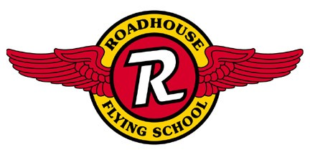
Welcome to Roadhouse Flying School!

The following information is intended to give future pilots an estimate of what it will cost them to complete their Private Pilot License here at Roadhouse Flying School. Please check with us for the most current information.

Price Guide for Private Pilot Course
FAA Minimum Requirements:
40 Hours Flight Time 20 Hours dual instruction
Due to the practical test standards set by the FAA. Few students complete their training in the minimum required time. We will train you to be proficient in the required maneuvers to pass the F.A.A. flight test.
The average private pilot applicant may expect approximately 50 hours total flight time. The following figures show the cost for a student who completes the course in 50 hours.
Plane Rental:

Aircraft | Hourly Rates | 10 Hour Block
C172 | $80.00 | $72.00
Plane Rental does not include Tax or Instructor Fees.

The average private pilot applicant may expect approximately 50 hours total flight time. The following figures show the cost for a student who completes the course in 50 hours. Flight hour prices shown are at the 10 hr. block rate.
Private Pilot |  | C172
50 Hours Flight Time |  | $3,600.00
30 Hours Flight Instruction |  | $900.00
20 Hours Ground |  | $600.00
Books, Fuel Tester |  | $170.00
F.A.A. Medical (3rd class) |  | $65.00
F.A.A. Written Exam |  | $80.00
F.A.A. Flight Test |  | $300.00
 |  | $5,715.00
** If you choose to pay as you go, it will cost approximately $6,115.00 in the Cessna 172
The above prices do not include tax.
All students are required to purchase a headset which is not included in the above cost.

Additional Ratings:

Instrument: 40 hours of Pilot in Command (PIC) Cross country: 40 Hours of instrument training.

Commercial: 20 hours of commercial training. To receive rating, pilot must have 250 total flight hours.

Ask about our Spatial Disorientation and High Altitude training, Upset Training, Aerobatics, as well as Multi-Engine instruction.
We also have on-line aircraft scheduling for our rental pilots and student pilots. This new service will give our pilots access to schedule our aircraft, flight instructors, and other resources on-line.
Call today and come take flight with Roadhouse Flying School. 918.296.0FLY(0359)

